The Cat
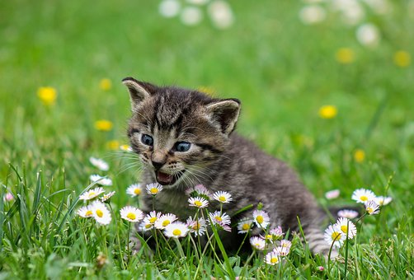

I hide unnoticed in the short green grass
Hopefully finding a small brown mouse to catch

I hear a rustle
I tense my paws
I set my legs
Then pounce on the
Soon to be dead

Mouse

Tadhg

The Fish

I swim around in my bowl
Waiting to be fed
I am not like any other pet
That needs walks, toys, or beds
I just need a nice backround
That makes me feel at home.

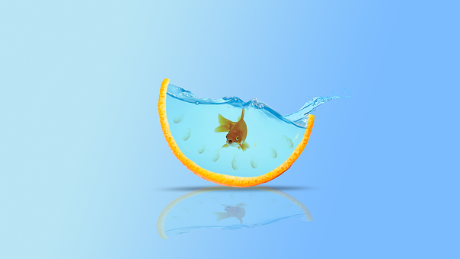

Donal

Black and White

Black and white
Strolling through the grass
Looking for shelter
Walking past small, tall, fat and slim
But...
Something caught my eye
A huge palm tree
I lay in the darkest part
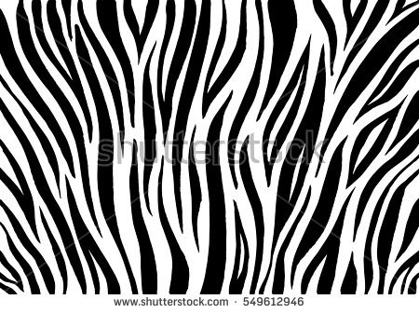
For I am a zebra
Black and White

Padraig

Crocodiles

I lurk underwater,
Waiting for my prey,
As a zebra gets his drink,
I pull it from the bay.

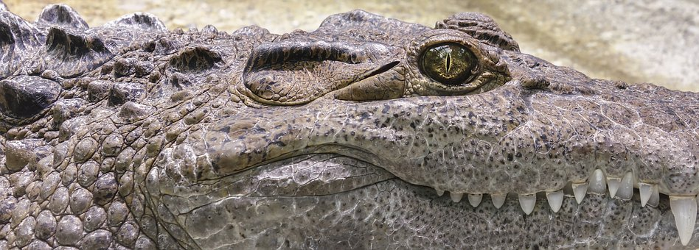

In the dead of night,
I try to swim away,
Praying that the hunters,
Won’t get their way
Ronan

Tortoise

Slow, steady and scaly
Would be a perfect way to describe my tortoise
Sleep all day,
Dig all night
He calmly waits for his fresh cucumber to be served
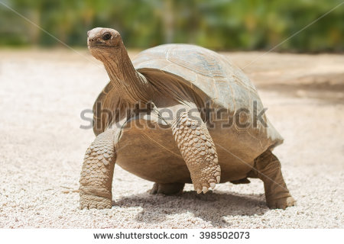
Sad, alone and afraid
Would be a perfect way to describe me
No one to play with,
No one to talk to
I long to be with my friends,
Roaming free in the wild
Máire

The Cat
Three in the morning,
I can’t sleep,
Just thinking about my breakfast,
Just munching away minding my own business
When will they wake up,
I start to close my eyes
Slowly falling into a deep sleep
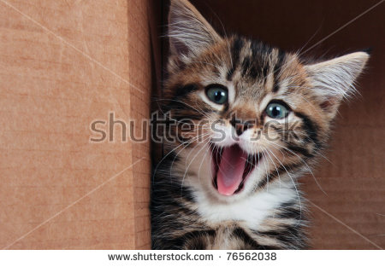

Casey

Dolphin

I’m the most elegant,
Most intelligent
Brilliant
Animal in the sea

I wait for humans to come
And then
I start jumping and flipping
The humans are amazed
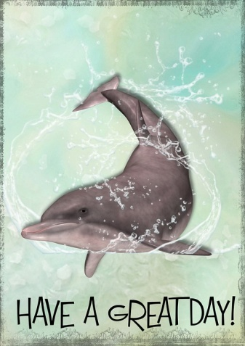
But then I’m tired
And go for a long snooze
I love performing
But I hate the toxic taste of oil
I wish..:)
Never mind they’ll never stop.
Lee
Im a cat.
Sly and lazy.
I sleep all day
And eat all the time
I wait and stare at the clock
Until I get bored.
Then I go break smething.

When my owner comes home
I wait by the food.
People call me stuborn
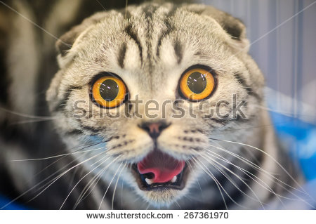
but im just a cat!

Chloe

Rabbit

I sprint across the vast green field,
Scared by the slightest move,
I scamper into the nearest burrow,

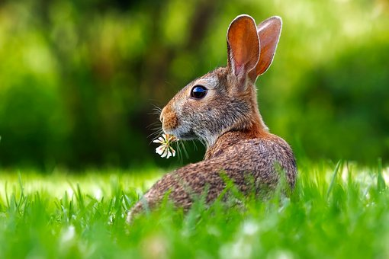

Feeling safe once more,
I never feel claustrophobic,
I just feel cosy
Tucked up in the dark burrow,
With my family by my side,
Their soft fur keeping me warm,
Away from the foxes outside

Leila

CAT
Proud, ancient cat
Sits on the window sill
Watching people pass
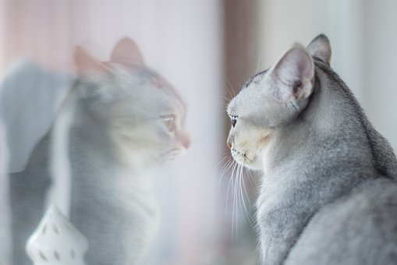
But another cat
Enters the territory
Vicious, angry cat
Scares the other

Victorious cat
Goes back to his basket
Waits to be cared for
Warm sleepy cat
Sits on his human’s
Lap
ANNELIESE

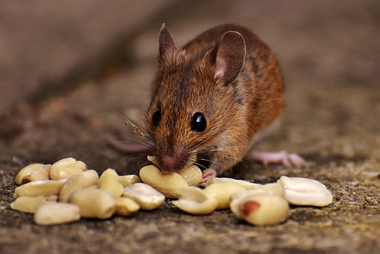

A Mouse
Small and skinny,
Quiet and sad,
Looking for something
To morsel on.

Crawling up the pipes
To keep myself from fright,
I hide in little nooks and crannies
So im not in their sight.

I don’t like the big people,
Who scream when I’m in sight,
I want them to know
I don’t want a fight.

I'm only a little mouse
Le Caolán

Cassie The Cow

I am hungry,
I am starving,
I am furry,
I am white and
I am definitely not light
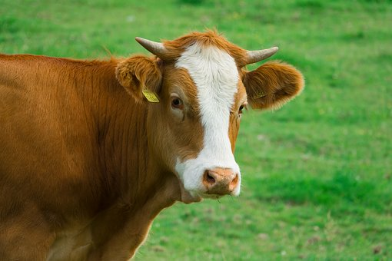
Waiting in my trailer,
Waiting to be hit.
Why am I here?
Waiting in fear

Marts Marts Marts
Why?
Why can’t cows be free?
I am Cassie
Cassie The Cow.

Niamh

CHANGE
I started off ugly
With a hard life
Teased mercilessly
Giving up my fight

One day I went to sleep
A very long sleep
I woke up refreshed
And started to fly
I felt amazing
I felt surprised
Flying around for hours
With a sparkle in my eye
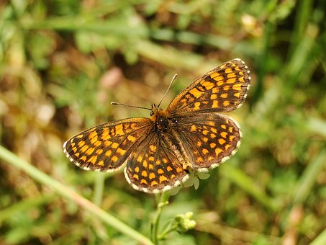
I started out ugly
But everything was worth it
I Love my life a lot
Thankful for everything I’ve got
Freya

Dog

Staring outside
I see a dog
Lonely and hungry
Fur tangled and dirty
How I long to find him a home

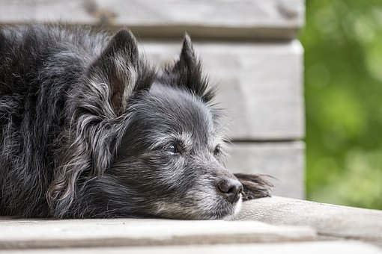

Staring inside
I see a dog
Pampered and fed
Fur fluffy and white
How I long to live in that home

Ella L

BLUE WHALE

When he reaches the the top,
He takes a huge breath,
He goes back down and swims around,
He scares the prey far, far away

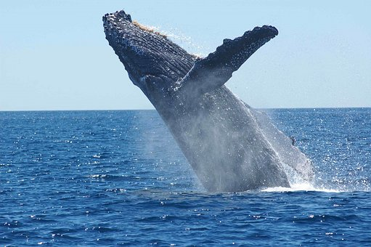

After a while he comes to the top,
You can see him jump,
High in the air,
But then he’s gone,
And not seen again.

Brooke

I’m a Dog called Daisy

I’m a dog called Daisy,
Lazy as could be,
Begging to be rubbed.
With my big brown eyes,
I’m royalty here.

I’m a dog called Daisy,
I’m warm and cosy inside,
While the other animals are outside,
In the cold Irish weather,
I’m royalty here.

I’m a dog called Daisy,
But I have made a mistake,
I ate the human’s dinner,
And got in trouble.

I’m outside now,
I’m no longer royalty here.

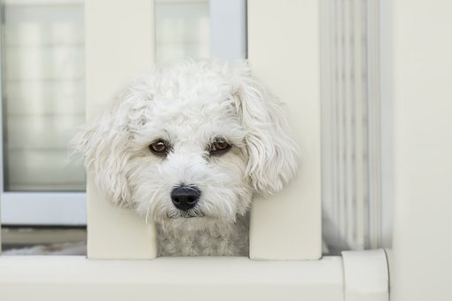

I’m a dog called Daisy
I’m back inside now,
I said sorry,
With my big brown sorry eyes,

They said,
Not to do it again,

I’m royalty here.

Isabel

I am a Zebra

I dip my head in the cool water of the open plain,
Taking as much as I can before the lions come.

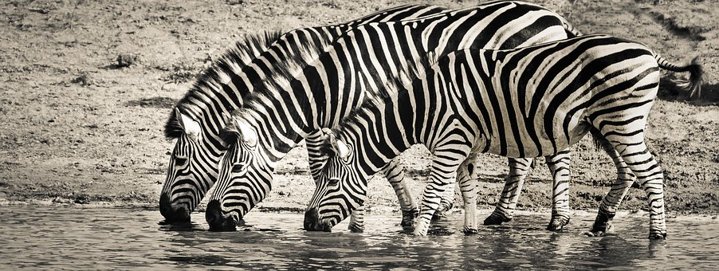

We all run as the lions come towards us,
As fast as they can.
We twist and turn
Dodging their sharp claws.

Some will fall some won’t.

Aenghus

Humans
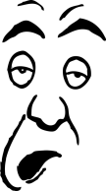
Humans,
Lazy, ignoble and above all, vain and selfish.
They let strange humans into their territory!
Humans
Creatures who appear to be stuck to their square toy, looking at a screen.
Humans
Creatures who wrap up in man-made fur.
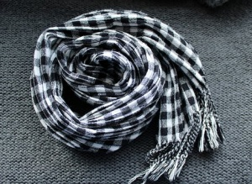
Humans
Creatures who think they rule the earth.
Creatures who communicate in a series of rolls
From their unnaturally pink tounge.
But I enjoy taking my pet human for walks around the park.
I tie a rope around their hand so that they don’t fall behind
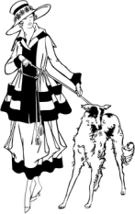 Muiris Ó Clochartaigh
My Pony Called Jet
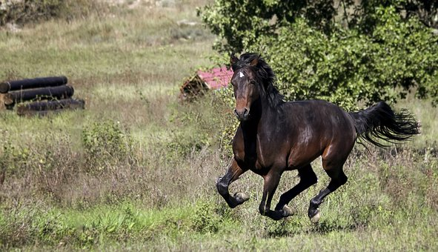
I walk around the corner,
My shrill call breaks through the air.
She turns her delicate head,
Eyes flashing.
She gallops towards the gate
Ploughing up the field,
With her powerful legs.
She lets out a few snorts of relief,
As she knows she’s coming in.

I lead her through the doorway,
All in a fluster
I lay down some fresh shavings,
She paws at the snow white substance,
Snorting as she lowers her strong body.
She rolls vigorously...Stands up
Nuzzles my shoulder,
As a thank you
I give her a treat
She yawns with pure joy.
Finally her strong body has drifted into a slumber
The lights turn off,
All is quiet
Alexandra
The Wait
As I wait for my owner to arrive home,
I look out the window.
I watch the cars drive past,
and I think about the yummy food that I will be eating.
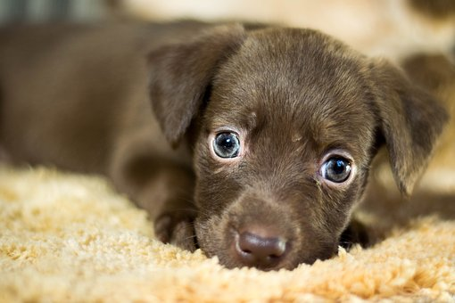
Hours go past and my owner still doesn’t arrive home.
My mouth is watering as I think about my food.
How long more?
I ask myself.
I finally hear my door unlock
I prance into my owner’s arms!
She pets my head and fills up my bowl with delicious food.
Oh I love my owner!

Dearbhla

CAT
Lazy, fat, black
Sleeps all day and night.
Never gets up unless he hears the nuts
Spill into the bowl
FOOD!!!
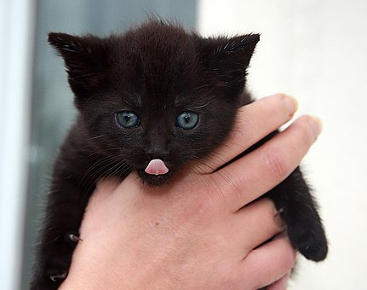
Runs from his bed,
MEOW!
He lets out a stretch,
Runs over.
He’s all full of food and energy, he’s ready!
HUNT!

A hunt to find something to play with
I am Poppy
Drew

Fox
Beautiful red soft fur
So mysterious and content as can be
I hear your song loud and clear
You were always my friend
Even when you were never near.
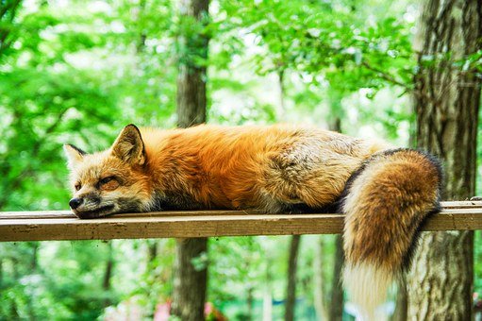

Caoimhin Speeckaert

Cheetah (Ríoghan)
i sneak in the grass
waiting
for my pray
so i can nibble on
as i run with speed
i pounce with
my claws digged into his leg
i have EateN my food
as i bring home my reward
home to my family
back at home starving
to death
with speed i go
as i’m a cheetah
who strikes fear
into my prey

